**A TECHNICAL REPORT ON STUDENT INDUSTRIAL WORK EXPERIENCE SCHEME (SIWES)**

**CARRIED OUT AT**

**TARABA BUSINESS SCHOOL,**

**JALINGO, TARABA STATE**

**FROM: 4TH JANUARY, 2023**

**TO: 4TH MAY, 2023**

**BY**

**KURUTSI GODWIN DANJUMA**

**ST/CS/ND/21/026**

**SUBMITTED TO**

**THE DEPARTMENT OF COMPUTER SCIENCE**

**SCHOOL OF SCIENCE AND TECHNOLOGY**

**FEDERAL POLYTECHNIC MUBI**

**IN PARTIAL FULFILLMENT FOR THE AWARD OF NATIONAL DIPLOMA (ND) IN COMPUTER SCIENCE**

**JUNE, 2023**

**DEDICATION**

I dedicate this report to the Almighty God for the guidance and protection accorded me throughout the programme.

# ACKNOWLEDGMENTS

I thank God Almighty for making me to undergo students industrial work experience scheme (SIWES) successfully.

My gratitude goes to my parent for their prayers, financial and moral support during my attachment.

I also appreciate the kind gesture of my brothers and sisters and those who supports me in prayers and contribution during my industrial attachment.

I whole heartedly thank my Head of department Mallam Adamu Garba Mubi, SIWES coordinator and all lectures of Computer Science for their effort to ensure my success as their students.

I am greatly indebted to my co-SIWES students to mention, may God strengthen our relationship together and grant us academic excellence.

I sincerely thank you all for your contribution and support.

**ABSTRACT**

*The report summarises the result of work done during my SIWES experience, the technical report consists of four chapters, which comprises of introduction, history and criteria’s of SIWES in chapter one followed by their aims and objectives, historical background, organizational structure of the organization in chapter two, while chapter three consist of the work and experience gained during the SIWES programme and lastly chapter four consist of the summary, conclusions and recommendation.*

**Table of Contents**

**Title page - - - - - - - - - - i**

**Approval page - - - - - - - - ii**

**Dedication - - - - - - - - - - iii**

**Abstract - - - - - - - - - - iv**

**CHAPTER ONE**

1.0 Introduction - - - - - - - - - 1

1.1 Background of SIWES - - - - - - - 1

1.2 Brief History of SIWES - - - - - - - 1

1.3 Aims and Objectives of SIWES - - - - - - 2

**CHAPTER TWO**

2.1 Brief History of the Organization. - - - - - - 3

2.2 Mission Statement - - - - - - - - 3

2.3 Vision statement - - - - - - - - 4

2.4 Organizational Chart - - - - - - - - 4

**CHAPTER THREE**

3.1 Computer Maintenance - - - - - - - 5

3.2 CorelDraw - - - - - - - - - 15

3.3 Microsoft Office Excel - - - - - - - 17

**CHAPTER FOUR**

4.1 Summary - - - - - - - - - 22

4.2 Conclusion - - - - - - - - - 22

4.3 Problems - - - - - - - - - 23

4.4 Recommendations - - - - - - - - 23

**CHAPTER ONE**

1. **INTRODUCTION**

The concept behind industrial training schemes is to acquire practical, knowledge in addition to what has been learn institution. The four months mandatory supervised industrial attachment is program instituted by the federal government to help student for their different field of studies.

* 1. **BACKGROUND OF SIWES**

It aims at exposing student to the practical and the actualization of work situation which they may meet after graduation and the learning is meanly expected to produce graduate qualification to meet man power of employments of (ITF), there was growing concern amount the industrialist that graduate of higher learning do not passes adequate background student for the opinion that theoretical education going higher institution was responsive enough to meet the need of employers of the labour as a requirement of national board for technical education (NBTE) polytechnic training before obtaining the National Diploma (ND).

Experience scheme (SIWES), is a National programme introduced by Government in 1974 for student in tertiary institution.

### 1.2 BRIEF HISTORY OF SIWES

**SIWES** was established by **ITF** in 1973 to solve the problem of lack of adequate practical skills preparatory for employment in industries by Nigerian graduates of tertiary institutions.

The program “Student industrial work experience scheme” is a pure skill-acquisition program structured for the tertiary institutions as a complementary and enhancement program to the theoretical education, laboratory and workshop practices engaged in by student in different higher institutions. The SIWES was initiated to improve the student’s technical abilities (performance/knowledge) and expose them to industrial culture thereby preparing them to be acquainted with the roles to play towards the technological advancement of the nation.

It is there for a practical aspect of the academic works, which the students may not be opportune to carry out throughout their stay in the higher institutions. Based on this fact, the Federal Government decided to establish a body (regulatory) which engages in the training of the technical manpower. The body is named industrial Training Fund (ITF). The government also undertook to make up for the deficiencies by structuring and established Students Industrial Training (SIT) as it was then called but in 1973 the SIWES was formed which is the subsidiary.

### 1.3 AIMS AND OBJECTIVES OF SIWES

1. One of the objectives of SIWES is to create an avenue for students to acquire industrial skills to complement their theoretical knowledge and improve their experiences in their course of study.
2. The program prepares the students for industrial working conditions prior to their graduation.
3. To enable the students to learn personal relationship with employers and co-employees on graduation.
4. It exposes the student to working methods and techniques in handling equipment and machinery.
5. It develops the student in make critical and realistic approaches to solving problem.
6. It serves as a way of improving the abilities of the students and to contribute to the growth of the nation.
7. It gives the students the opportunity to practice what they have been taught in various disciplines.
8. The SIWES program strengthens the employer’s involvement in preparing the students for employment.

**CHAPTER TWO**

**2.1 BRIEF HISTORY OF TARABA BUSINESS SCHOOL**

Taraba Business School is a training institute that was established in 2015 By Mr Gabriel Olayinka who is a chartered Accountant. The school got registered with the Corporate Affairs Commission on the 9th of Dec, 2016. Approved by Taraba State Govt on 23rd, March 2017. It is also affiliated to the institute of chartered Accountants of Nigeria. (ICAN) it got a certificate of recognition on the 6th of April 2017. Taraba Business School is involved in the following: Computer/ ICT, Accountants among other trades.

**2.2 ORGANIZATIONAL CHART**

Figure 2.1: Organizational Chart

**CHAPTER THREE**

**EXPEREIENCE GAINED**

**3.1 INTRODUCTION TO MICROSOFT WORD**

Microsoft word is a word processing package was designed initially for document. Microsoft word (MS-Word) is an application package which designed and created to solve problem. Or Microsoft word is a word processing package designed to make work easy, Microsoft word is designed purposely for typing of document, report, memos, and letter etc.

**Types of document that can be processed include:**

1. Letter
2. Memo
3. Books
4. Magazine

**3.1.1 USES OF MICROSOFT WORD.**

Microsoft word is referred to as word processing package. The

**Uses of Microsoft are:**

1. Edit
2. Arrange
3. Typesetting of documents, etc.

**3.1.2 HOW TO LAUNCH MICROSOFT WORD.**

1. Click on start button on the task bar window 7)
2. Move the mouse pointer to programs or select all programs
3. Click on Microsoft word

OR

1. Double click on the desktop environment.
2. Then the Microsoft word will open

**3.1.3 HOW TO SAVE WORK IN MICROSOFT WORD (MS-WORD).**

1. Click on file
2. Select save as if you are saving the work for the first time
3. A dialog box will appear
4. Type the file name and click on save.

**3.1.4 HOW TO INSERT TABLE IN MS- WORD.**

1. Click on insert on the menu bar
2. Click on table
3. Click table
4. Click insert table on the drop down menu.
5. Select the number of Columns and Rows
6. Click ok

**3.1.5** **MICROSOFT WORD ENVIRONMENT.**



Figure 3.1: Microsoft Word Viewed Screen.

1. The title bar: wherever you saved any work, the file name and reside on the title bar
2. The menu bar: menu bar is made up of (file, edit, view, insert, format, tools, table, and window help).
3. The standard tool bar: consist of spelling and grammar icon, help.
4. The formatting tools bar: contain **(Bold (B), *(I), Italic* underline (U).**
5. **The drawing tools bar:** consist of any thin like auto shape, square, circle, text, word art pie chart, and bar chart etc.
6. **The insertion point:** or cursor is a place where you can insert table, row column etc.
7. **The ruler:** rule is mean for adjusting the MS-word environment etc.

**3.2 INTRODUCTION TO COREL DRAW**

**CORELDRAW:** is a software application package used mostly for graphic system designed. It is written by CorelDraw system cooperation and runs on Microsoft windows. It is known to be one of the best design graphic software. It uses mean to carry out most task operation need to created design and pattern.

**3.2.1 ADVANTAGE OF CORELDRAW.**

1. is easy to create graphics and design.

2. In the CorelDraw there is room for text entry and design.

3. In CorelDraw these enhancement tool for measuring and object.

4. It allowed us to manipulate graphics more than one.

**3.2.2 WAYS OF LOADING CORELDRAW.**

There are two basic ways which is mentioned below:

1. Click on start on the task bar (i.e. windows 7)
2. Click on all program.
3. Select CorelDraw. OR
4. Double click the icon on the desktop environment.

**3.2.3 DIFFERENT VERSION OF CORELDRAW.**

There are many tools in CorelDraw and here are few of them listed below.

1. Version 8
2. Version 9
3. Version 10
4. Version 11
5. Version 12
6. Version 13
7. Version 14
8. Version 17…e.t.c

**3.2.4 CORELDRAW TOOLS.**

There are many tools in CorelDraw and here are few of them listed below.

1. Pick tool
2. Shape tool
3. Eraser tool
4. Knife tool
5. Zoo tool
6. Hand tool
7. Free hand tool
8. Rectangle tool
9. Polygon tool
10. Eclipse tool
11. Artistic media

**3.2.5 HOW TO FIT TEXT TO PATH**

Fit text to path means making text to be in a circle or round from or any shape of your choice.

Below are steps of how to do it. Create the text and the shape style you want to use for your fit text path.

1. Highlight the destination path.
2. Select text
3. Go to text menu
4. Click on fit text to path command
5. Move your mouse pointer to hit destination path and click ok button.

**3.2.6 HOW POWERCLIP OBJECT**

An object created by placing object (contents objects) inside other (container objects).

**TO CREATE A POWERCLIP OBJCT**

1. Click pick tool
2. Click the object
3. Click Effect on the menu bar
4. Click PowerClip.
5. Click place inside container

**Designed Zenith Bank Logo**



Zenith Bank Logo in CorelDraw

**3.3 MICROSOFT EXCEL**

Microsoft Excel is a program that manipulates data in rows and columns. It enables you to store not only numerical data but also formulae to carry out operations on the numerical data. So a formula apply to one the spreadsheet may determine the values shown in another part. If data in one area of the spreadsheet is changed, the adjustment are made automatically to other area.

**3.3.1 DEFINATION OF SOME BASIC MICROSOFT EXCEL TERMS**

1. **Rows:** These run left to right across the windows and their position is designated by a number.
2. **Columns:** These run from top to bottom of the window and their position is designated by a letter.
3. **Cell Reference:** is formed by combining the column position and row position.
4. **Label:** is a text entry. We use label to identify what we are talking about.
5. Value: is piece of data that can be used in calculation.

**MICROSOFT OFFICE EXCEL 2013 WINDOW.**

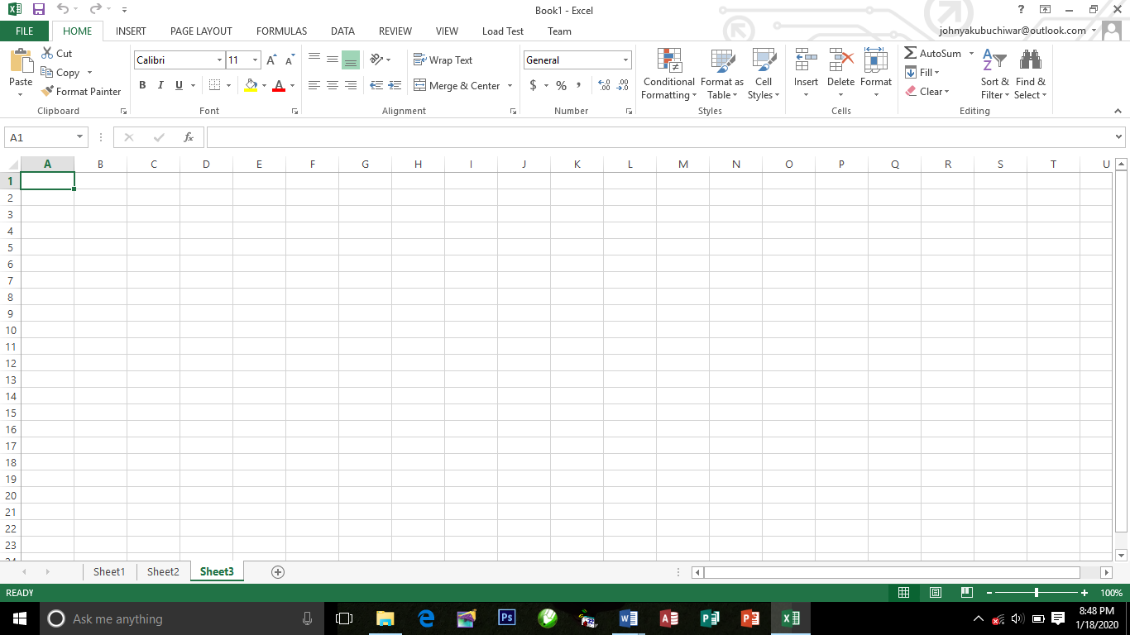

**SOME SPECIFICATION AND LIMITS IN EXCEL**

1. Number of Rows = 65,536
2. Number of Columns = 256 (from A to IV)
3. Columns can hold up to = 255 characters

**3.3.2 TYPES OF OPERATION IN EXCEL.**

Arithmetic operation:

To perform basic mathematical operation such as addition, subtraction, or multiplication, combine numbers, and produce numeric result, use the following arithmetic operations.

**Arithmetic operation Meaning (Example)**

+ (Plus sign) Addition (3+3)

- (minus sign) Subtraction (4-1)

* (asterisk) Multiplication (3*3)

/ (forward sign) Division (3/)

% (percent sign) Percent (20%)

^ (caret sign) Exponentiation (3^2)

SQRT Square root sqrt(19)

AVERAGE. Average of the rage of cells average (A1:A15)

**EXAMPLES:**

Formula in Microsoft excel to solve the following questions

1. 2+3
2. 32+52
3. 67-

**SOLUTION:**

=2+3

=3^2+52

=67-SQRT(23)

**HOW TO CALCULATE EMPLOYEE SALARY**

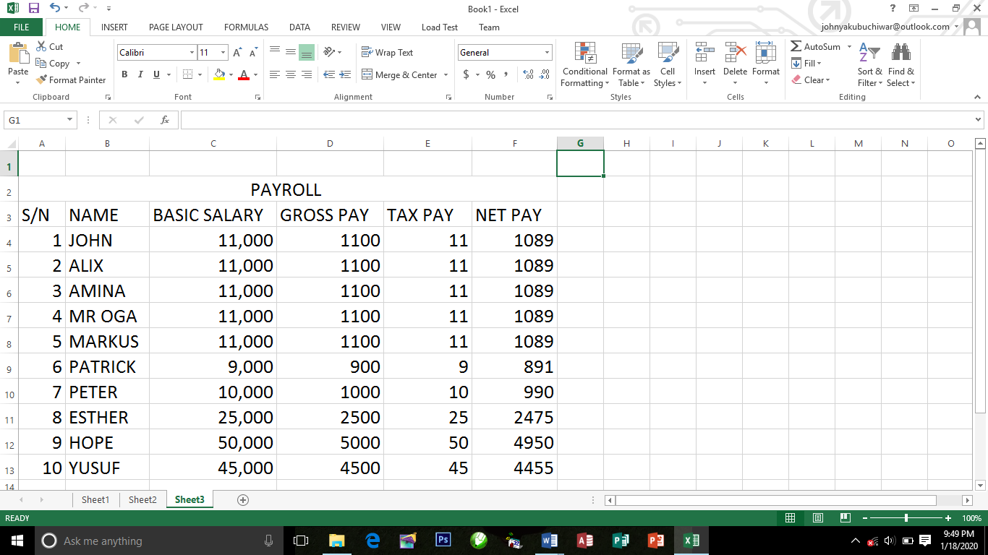

**HINT:**

1. Allowance = 10%* of Basic salary
2. Gross pay = Allowance + Basic salary
3. Tax pay = 1%* of Gross pay
4. Net par = Gross pay Tax pay

**3.4 INTRODUCTION to HTML**

**3.4.1 What is HTML?**

1. HTML is the standard markup language for creating Web pages.
2. HTML stands for Hyper Text Markup Language
3. HTML describes the structure of Web pages using markup
4. HTML elements are the building blocks of HTML pages
5. HTML elements are represented by tags

**HTML Tags**

HTML tags are element names surrounded by angle brackets:

<tagname>content goes here...</tagname>

1. HTML tags normally come in pairs like <p> and </p>
2. The first tag in a pair is the start tag, the second tag is the end tag

**WEB BROWSERS**

The purpose of a web browser (Chrome, IE, Firefox, Safari) is to read HTML documents and display them. The browser does not display the HTML tags, but uses them to determine how to display the document:

**HTML VERSIONS**

Since the early days of the web, there have been many versions of HTML:

**Version Year**

HTML 1991

HTML 2.0 1995

HTML 3.2 1997

HTML 4.01 1999

XHTML 2000

HTML5 2014

**HTML EDITORS**

Web pages can be created and modified by using professional HTML editors.

1. Notepad (Windows) or TextEdit (Mac).
2. Sublime
3. Notepad ++
4. Atom, etc.

We believe using a simple text editor is a good way to learn HTML.

Follow the four steps below to create your first web page with Notepad or TextEdit.

**HTML PARAGRAPHS**

HTML paragraphs are defined with the <p> tag:

Example

<p>This is a paragraph.</p>

<p>This is another paragraph.</p>

**HTML Headings**

Headings are important in HTML documents. Headings are defined with the <h1> to <h6> tags.

<h1> defines the most important heading. <h6> defines the least important heading.

Example

<h1>This is heading 1</h1>

<h2>This is heading 2</h2>

<h3>This is heading 3</h3>

<h4>This is heading 4</h4>

<h5>This is heading 5</h5>

<h6>This is heading 6</h6>

**HTML Text Formatting Elements**

**Tag Description**

<b> Defines bold text

<em> Defines emphasized text

<i> Defines italic text

<small> Defines smaller text

<strong> Defines important text

<sub> Defines subscripted text

<sup> Defines superscripted text

<ins> Defines inserted text

<del> Defines deleted text

<mark> Defines marked/highlighted text

**HTML Comments**

Comment tags are used to insert comments in the HTML source code.

You can add comments to your HTML source by using the following syntax:

<!-- Write your comments here -->

With comments you can place notifications and reminders in your HTML:

Example

<!-- This is a comment -->

<p>This is a paragraph.</p>

<!-- Remember to add more information here -->

»

**HTML Colors**

In HTML, a color can be specified by using a color name, an RGB value, or a HEX value.

**Color Names**

In HTML, a color can be specified by using a color name:

Example

**Color Name**

Red

Orange

Green

Black

HTML supports 140 standard color names.

**RGB Value**

rgb(255,0,0)

rgb(255,255,0)

**HEX Value**

In HTML, a color can also be specified using a hexadecimal value in the form: #RRGGBB, where RR (red), GG (green) and BB (blue) are hexadecimal values between 00 and FF (same as decimal 0-255). For example, #FF0000 is displayed as red, because red is set to its highest value (FF) and the others are set to the lowest value (00).

Example

**HEX Value**

#FF0000

#FFFF00

#CCCCCC

#FFFFFF

**HTML Links**

Links are found in nearly all web pages. Links allow users to click their way from page to page.

**HTML Links - Hyperlinks**

HTML links are hyperlinks. You can click on a link and jump to another document.

When you move the mouse over a link, the mouse arrow will turn into a little hand.

**Note**: A link does not have to be text. It can be an image or any other HTML element.

**HTML Images**

JPG Images

GIF Images

PNG Images

Example

<!DOCTYPE html>

<html>

<body>

<h2>Spectacular Mountain</h2>

<img src="pic_mountain.jpg" alt="Mountain View" style="width:304px;height:228px; ">

</body>

</html>

»

**HTML Images Syntax**

In HTML, images are defined with the <img> tag. The <img> tag is empty, it contains attributes only, and does not have a closing tag. The src attribute specifies the URL (web address) of the image:

<img src="url" alt="some_text" style="width:width;height:height;">

If a browser cannot find an image, it will display the value of the alt attribute:

Example

<img src="wrongname.gif" alt="HTML5 Icon" style="width:128px;height:128px;">

**HTML Lists**

**Unordered HTML List**

An unordered list starts with the <ul> tag. Each list item starts with the <li> tag.

The list items will be marked with bullets (small black circles) by default:

Example

<ul>

<li>Coffee</li>

<li>Tea</li>

<li>Milk</li>

</ul>

**Ordered HTML List**

An ordered list starts with the <ol> tag. Each list item starts with the <li> tag.

The list items will be marked with numbers by default:

Example

<ol>

<li>Coffee</li>

<li>Tea</li>

<li>Milk</li>

</ol>

**Ordered HTML List - The Type Attribute**

The type attribute of the <ol> tag, defines the type of the list item marker:

**Type Description**

type="1" The list items will be numbered with numbers (default)

type="A" The list items will be numbered with uppercase letters

type="a" The list items will be numbered with lowercase letters

type="I" The list items will be numbered with uppercase roman numbers

type="i" The list items will be numbered with lowercase roman numbers

## 3.5 What is CSS?

**CSS** stands for **C**ascading **S**tyle **S**heets. CSS describes **how HTML elements are to be displayed on screen, paper, or in other media.** CSS **saves a lot of work**. It can control the layout of multiple web pages all at once. External stylesheets are stored in **CSS files**. CSS is a language that describes the style of an HTML document.

### CSS Example

body {  
    background-color: lightblue;}  
 h1 {  
    color: white;  
    text-align: center;}  
p {  
    font-family: verdana;  
    font-size: 20px;}

## Applying CSS

There are three ways to apply CSS to HTML: **Inline**, **internal**, and **external**.

## Inline

Inline styles are plonked straight into the HTML tags using the style attribute.

They look something like this:

<p style="color: red">text</p>

This will make that specific paragraph red.

But, if you remember, the best-practice approach is that the HTML should be a stand-alone, **presentation free** document, and so in-line styles should be avoided wherever possible.

## Internal

Embedded, or internal, styles are used for the whole page. Inside the [head](http://www.htmldog.com/references/html/tags/head/) element, the [style](http://www.htmldog.com/references/html/tags/style/) tags surround all of the styles for the page.

<!DOCTYPE html>

<html>

<head>

<title>CSS Example</title>

**<style>**

**p {**

**color: red;**

**}**

**a {**

**color: blue;**

**}**

**</style>**

This will make all of the paragraphs in the page red and all of the links blue.

Although preferable to soiling our HTML with inline presentation, it is similarly usually preferable to keep the HTML and the CSS files separate, and so we are left with our saviour.

## External

External styles are used for the whole, multiple-page website. There is a **separate CSS file**, which will simply look something like:

p {

color: red;

}

a {

color: blue;

}

If this file is saved as “style.css” in the same directory as your HTML page then it can be linked to in the HTML like this:

<!DOCTYPE html>

<html>

<head>

<title>CSS Example</title>

<link rel="stylesheet" href="style.css">

...

# CSS Syntax and Selectors

## CSS Syntax

A CSS rule-set consists of a selector and a declaration block:

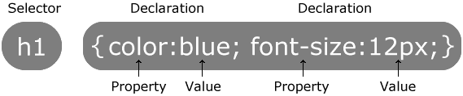

The selector points to the HTML element you want to style. The declaration block contains one or more declarations separated by semicolons. Each declaration includes a CSS property name and a value, separated by a colon.

A CSS declaration always ends with a semicolon, and declaration blocks are surrounded by curly braces.

## Lengths and Percentages

There are many property-specific units for values used in CSS, but there are some general units that are used by a number of properties and it is worth familiarizing yourself with these before continuing.

* **px** (such as font-size: 12px) is the unit for pixels.
* **em** (such as font-size: 2em) is the unit for the calculated size of a font. So “2em”, for example, is two times the current font size.
* **pt** (such as font-size: 12pt) is the unit for points, for measurements typically in printed media.
* **%** (such as width: 80%) is the unit for… wait for it… percentages.

Other units include picas, centimeters, millimeters and inches.

## CSS Selectors

CSS selectors are used to "find" (or select) HTML elements based on their element name, id, class, attribute, and more.

## The Element Selector

The element selector selects elements based on the element name. You can select all <p> elements on a page like this (in this case, all <p> elements will be center-aligned, with a red text color):

### Example

p {  
    text-align: center;  
    color: red;  
}

## The id Selector

The id selector uses the id attribute of an HTML element to select a specific element. The id of an element should be unique within a page, so the id selector is used to select one unique element! To select an element with a specific id, write a hash (#) character, followed by the id of the element.

The style rule below will be applied to the HTML element with id="para1":

### Example

#para1 {  
    text-align: center;  
    color: red;  
}

## The Class Selector

The class selector selects elements with a specific class attribute. To select elements with a specific class, write a period (.) character, followed by the name of the class.

In the example below, all HTML elements with class="center" will be red and center-aligned:

### Example

.center {  
    text-align: center;  
    color: red;  
}

## CSS Comments

Comments are used to explain the code, and may help when you edit the source code at a later date. A CSS comment starts with /* and ends with */. Comments can also span multiple lines:

### Example

p {  
    color: red;  
    /* This is a single-line comment */  
    text-align: center;  
}

**3.6 INTRODUCTION TO JAVASCRIPT**

**3.6.1 WHAT IS JAVASCRIPT**

JavaScript is a programming language, and like most programming languages, it has some basic constructs that we’ll look at. A program in JavaScript is like a sequence of steps. Similar to how we give directions to a stranger, a computer needs detailed instructions, defined as steps, to accomplish any simple or complex action.

**3.6.2 HOW TO INSERT JAVASCRIPT**

JavaScript can be added to your HTML file in [two ways](https://www.geeksforgeeks.org/where-to-put-javascript-in-an-html-document/):

1. **Internal JS:** We can add JavaScript directly to our HTML file by writing the code inside the <script> tag. The <script> tag can either be placed inside the <head> or the <body> tag according to the requirement.
2. **External JS:** We can write JavaScript code in other file having an extension.js and then link this file inside the <head> tag of the HTML file in which we want to add this code.

**Syntax:**

<script>

// JavaScript Code

</script>

**Variables in JavaScript**

Variables in JavaScript are containers that hold reusable data. It is the basic unit of storage in a program.

1. The value stored in a variable can be changed during program execution.
2. A variable is only a name given to a memory location, all the operations done on the variable effects that memory location.
3. In JavaScript, all the variables must be declared before they can be used.

**Before ES2015**, JavaScript variables were solely declared using the *var* keyword followed by the name of the variable and semi-colon. Below is the syntax to create variables in JavaScript:

*var* var_name;

*var x;*

Below are some examples of declaring and initializing variables in JavaScript:

*// declaring single variable*

**var name;**

*// declaring multiple variables*

**var name, title, num;**

*// initializing variables*

**var name = "Harsh";**

**name = "Rakesh";**

**After ES2015**, we now have two new variable containers: let and const. Now we shall look at both of them one by one. The variable type **Let** shares lots of similarities with var but unlike var, it has scope constraints. To know more about them visit [let vs var](https://www.geeksforgeeks.org/difference-between-var-and-let-in-javascript/). Let’s make use of the let variable:

*// let variable*

let x; // undefined

let name = 'Mukul';

*// can also declare multiple values*

let a=1,b=2,c=3;

*// assignment*

let a = 3;

a = 4; // works same as var.

**Const** is another variable type assigned to data whose value cannot and will not change throughout the script.

// const variable

const name = 'Mukul';

name = 'Mayank'; // will give Assignment to constant variable error.

**CHAPTER FOUR**

**SUMMARY, CONCLUSION, PROBLEMS AND RECOMMENDATIONS**

## 4.1 SUMMARY

The relevance of the SIWES program cannot be over emphasized considering the fact that it has significantly reduced the gap between my theoretical and practical knowledge about computer hardware and software, installations, maintenance and networking. The processes of communication which include data and telecommunication the use of switch in the networking and what networking is all about.

The program is indeed a commendable one in that it affords students ample opportunities of being exposed to good working relationship with colleagues and the field experience with customers. This little exposure has widened my knowledge about my course of study, not only that it has automatically changed my views about lift in general. The firm at large has taught me how to be independent of my own how to be conscious of my health and safety at its peak relating to the environment where I carried out my SIWES program. It was indeed a highly rewarding experience to be with Taraba Business School, Jalingo, Taraba State, Nigeria.

**4.2 CONCLUSION**

In conclusion, I thank ITF in general for their effort towards the Student Industrial Training Scheme. The contribution that the industrial training offered to student will not be over emphasized. It has exposed me seriously to a certain depth and length of practical capability on Computer Knowledge and practical Know how.

It has also acquainted me with the working condition, which I am expected to encounter in the near future. I will say that SIWES has a greater advantage on me, it has greatly exposed me to the practical application of all that I have been through in the school, SIWES is an experience that all student must pass through this is because it gives a full practical knowledge of what has been through in classroom.

Finally, I have a strong believe that this comprehensive based on the experience, I acquired during the industrial training scheme will convince every user training is not difficult.

I therefore strong conclude that the continuous existence of SIWES programme as it is very necessary since it plays a dominant role in the development of student of Computer Science in the acquisition of practical experience.

## 4.3 PROBLEMS OBSERVED DURING MY PROGRAM

1. The time frame set for the program is too short as some of the aspects of the program where not completed.
2. Lack of Financial support from the company to aid transportation to and from training.
3. Attentions are not given to the IT students by the workers it is learn if you want to learn or ask if you want to know.
4. Cost of Training: The Student has to be registered as a student of a particular organization in order to carry out the program.

**4.4 RECOMMENDATIONS**

Below are the recommendations that should be given serious consideration so as alleviate the suffering of students undergoing SIWES.

Firstly, the Federal Government of Nigerian should make a positive effort in reducing the overall cost of production so that companies should be producing to fill capacity and accommodate SIWES populaces. Also, certain monthly allowance may be given to the student by company accepted then (student to ease transportation problem).

Secondly, the Industrial Training Fund (ITF), should try and increase the money paid at the end of SIWES to the student so as to justify the Cost of Living we experienced.

Finally, the ITF official should please continue visiting the students, to ensure that what they are learning is in line with the ITF requirement.

**REFERENCES**

Edward, B. M.D (2003). The Effect of SIWES on a student, Federal Ministry of Works, Lagos. Nigeria.

John, Doe (2008). Introduction to web development: responsive designs, McGraw Print New York.